Burger Sales Analysis Using SQL
1)What is the total number of orders?
SELECT SUM(Orders) AS total_orders
FROM the_burger_spot;
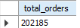
2)Which area has the highest number of orders?
SELECT area, SUM(orders) AS total_orders
FROM the_burger_spot
GROUP BY area
ORDER BY total_orders DESC
LIMIT 1;
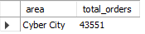
3)Which area has the lowest number of orders?
SELECT area, SUM(orders) AS total_orders
FROM the_burger_spot
GROUP BY area
ORDER BY total_orders ASC
LIMIT 1;
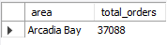
4) What are the total orders for each area?
SELECT area, SUM(orders) AS total_orders
FROM the_burger_spot
GROUP BY area
ORDER BY total_orders DESC;;
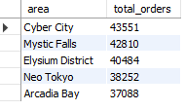
5)Which item is the most ordered?
SELECT item, SUM(orders) AS total_orders
FROM the_burger_spot
GROUP BY item
ORDER BY total_orders DESC
LIMIT 1;
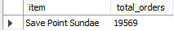
6)Which item is the least ordered?
SELECT item, SUM(orders) AS total_orders
FROM the_burger_spot
GROUP BY item
ORDER BY total_orders ASC
LIMIT 1;

7)What are the total orders for each item?
SELECT item, SUM(orders) AS total_orders
FROM the_burger_spot
GROUP BY item
ORDER BY total_orders DESC;
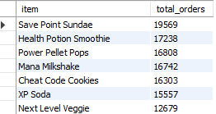

8) Which category has the highest orders?
SELECT category, SUM(orders) AS total_orders
FROM the_burger_spot
GROUP BY category
ORDER BY total_orders DESC
LIMIT 1;
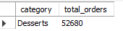
9)What are the total orders for each category?
SELECT category, SUM(orders) AS total_orders
FROM the_burger_spot
GROUP BY category
ORDER BY total_orders DESC;
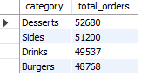
10) Which type of order is most common (Dine-in / Online / Takeaway)?

SELECT Type_of_Order, SUM(Orders) AS total_orders
FROM the_burger_spot
GROUP BY Type_of_Order
ORDER BY total_orders DESC
LIMIT 1;
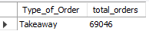

11)What are the total orders for each type of order?
SELECT Type_of_Order, SUM(Orders) AS total_orders
FROM the_burger_spot
GROUP BY Type_of_Order
ORDER BY total_orders;

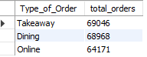

12)How many orders happened on each date?
SELECT date, SUM(Orders) AS total_orders
FROM the_burger_spot
GROUP BY date
ORDER BY date;

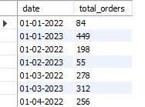
13)Which date has the highest orders?
SELECT date, SUM(Orders) AS total_orders
FROM the_burger_spot
GROUP BY date
ORDER BY total_orders desc
limit 1;

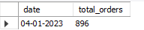
14)Which date has the lowest orders?
SELECT date, SUM(Orders) AS total_orders
FROM the_burger_spot
GROUP BY date
ORDER BY total_orders
limit 1;
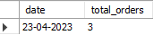

15)What is the total orders trend over time?
SELECT Date, SUM(Orders) AS total_orders
FROM the_burger_spot
GROUP BY Date
ORDER BY Date;
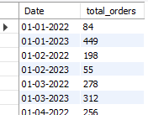
16)Which area and category combination has the highest orders?
SELECT area,category, SUM(Orders) AS total_orders
FROM the_burger_spot
GROUP BY area,category
ORDER BY total_orders desc
limit 1;
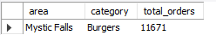

17)What are the top 5 most ordered items?
SELECT ITEM,
SUM(ORDERS)AS TOTAL_ORDERS
FROM THE_BURGER_SPOT
GROUP BY ITEM
ORDER BY TOTAL_ORDERS DESC
LIMIT 5;
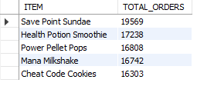

18)What are the bottom 5 least ordered items?
SELECT ITEM,
SUM(ORDERS)AS TOTAL_ORDERS
FROM THE_BURGER_SPOT
GROUP BY ITEM
ORDER BY TOTAL_ORDERS ASC
LIMIT 5;
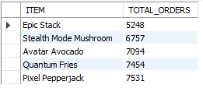

19)Which area gives the highest online orders?
SELECT area, SUM(Orders) AS total_orders
FROM the_burger_spot
where type_of_order = 'online'
GROUP BY area
ORDER BY total_orders desc
limit 1;

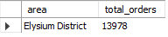

20)Which category is most popular in each area?
SELECT Area, Category, SUM(Orders) AS total_orders
FROM the_burger_spot
GROUP BY Area, Category
ORDER BY Area, total_orders DESC;
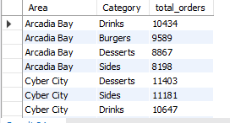
Conclusion:
This project analyzed burger sales data using MySQL to identify customer ordering patterns, popular menu items, high-performing areas, and order trends over time. The insights obtained from SQL queries can be further visualized using Power BI dashboards to support business decision-making and improve restaurant performance.

